**iTrent Booking and Cancellation Guide**

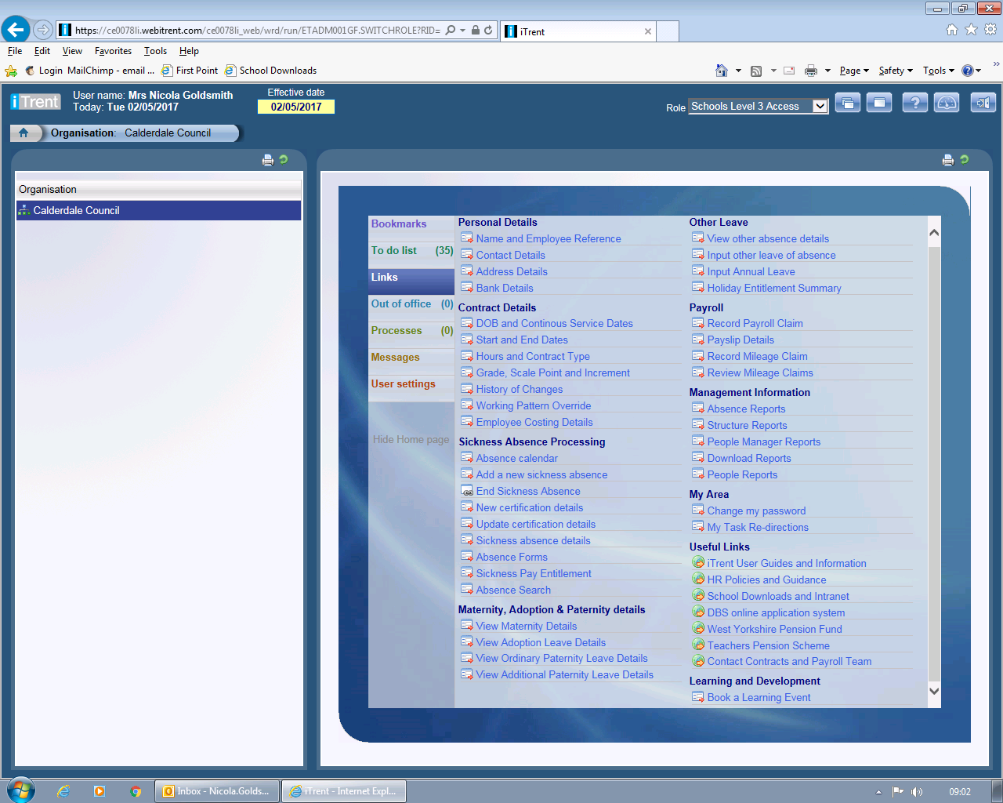**How to Book**

Click on the “Book a Learning Event” link on the bottom right hand side of your “quick links” page

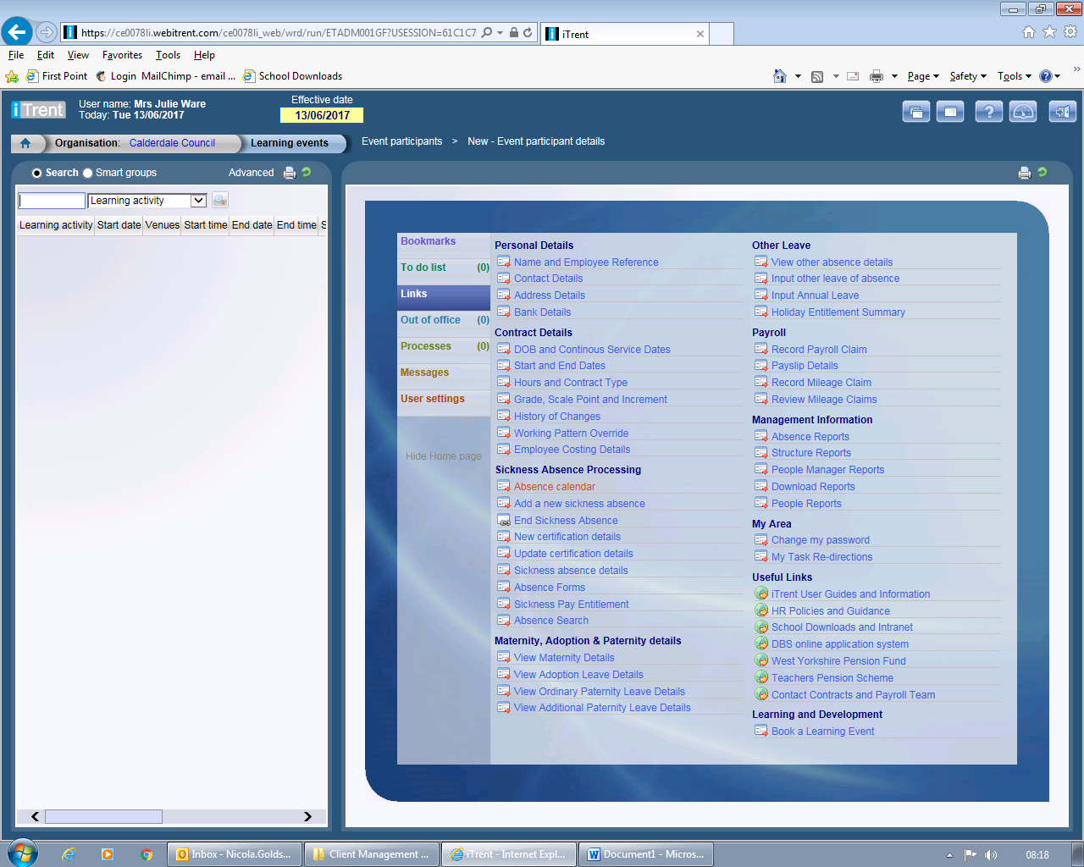

In the box on the left hand side type a *and a key word from the course title as detailed in the learning guide. We do not recommend using just a * as this will list all historical events.

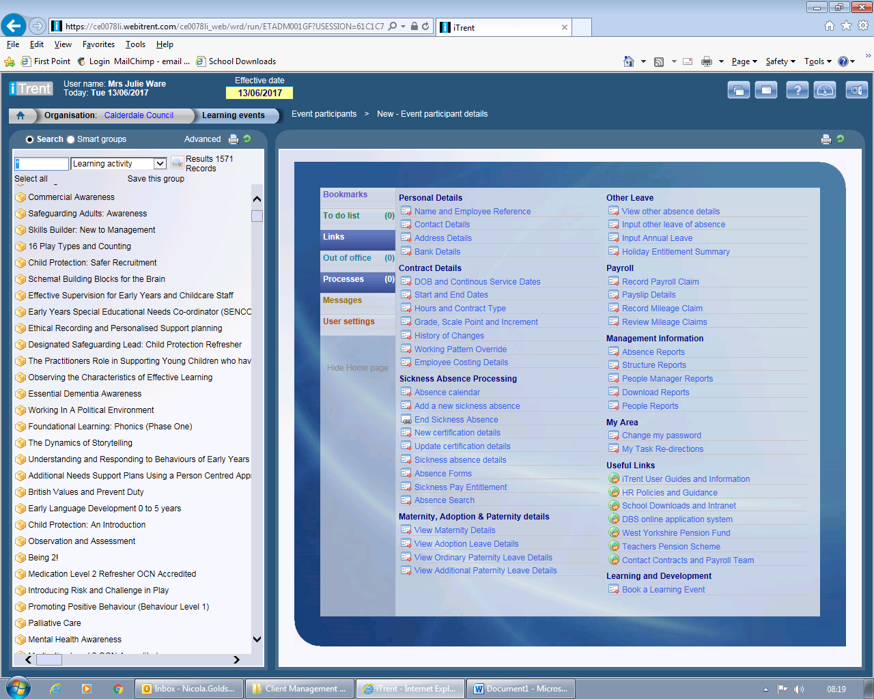

A list of courses will appear in descending date order. Hover over the title and the date and time of the course will appear in a pop-up box. Click on the course title for the date you require.

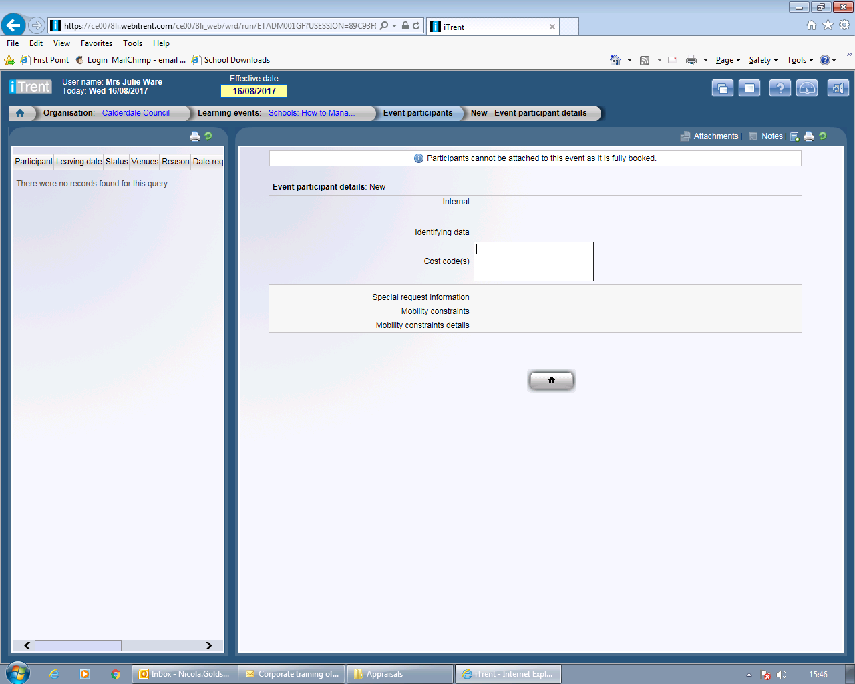

This message will be displayed if the course is fully booked

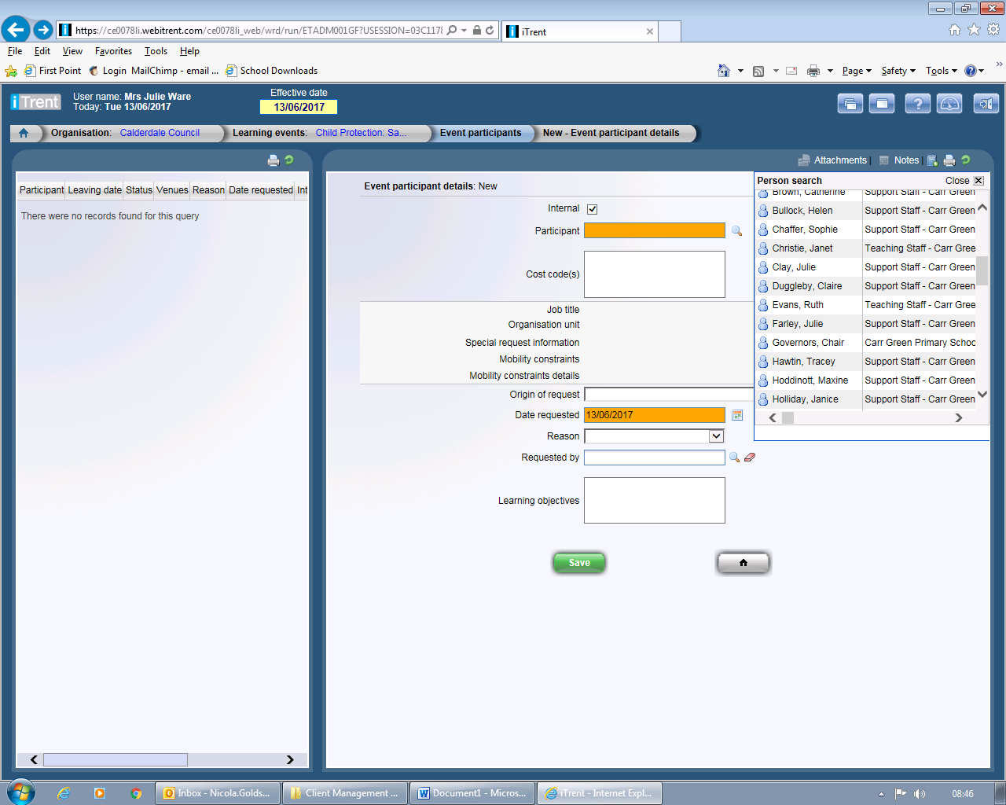

To add a delegate click the magnifying glass to open a search box. Enter the surname in the box and click the magnifying glass, then click on the person to select them. Complete the details on the form. Purchase Order Numbers should be entered in the Cost code box. Enter your name in the Requested By box then click Save.

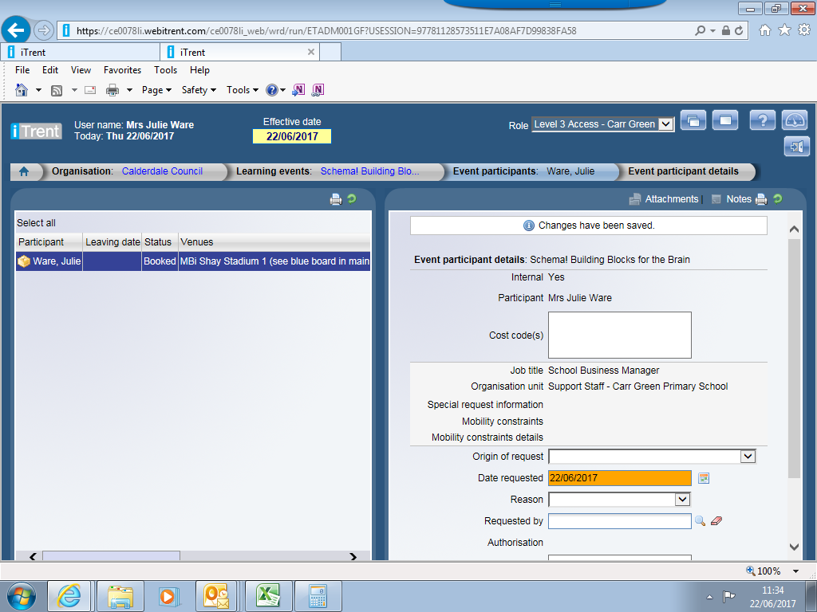

The delegate will now appear in the LH side of the screen confirming the status of the booking. The system will auto generate and send a confirmation directly from [noreply@ce0078.webitrent.com](mailto:noreply@ce0078.webitrent.com). Any pre-course reading material will be emailed nearer the time.

**Cancelling a place on a course**

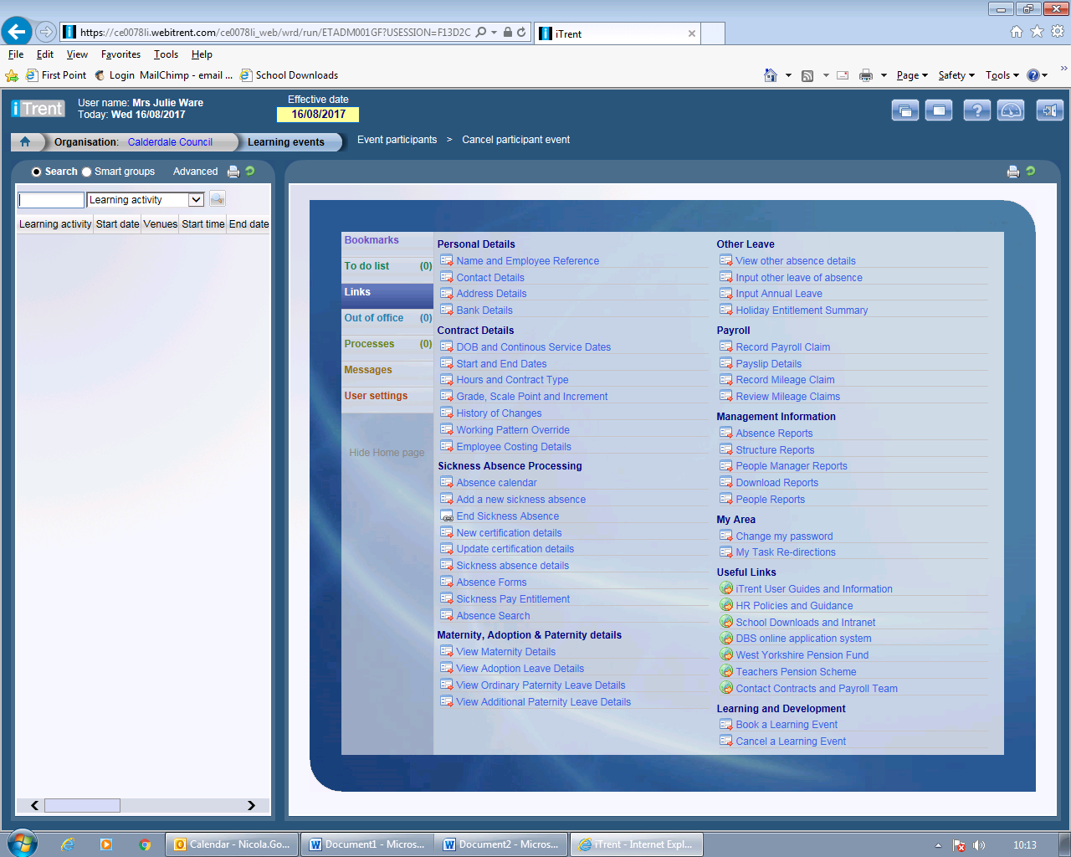

Click on the “Cancel a Learning Event” link on the bottom right hand side of your “quick links” page

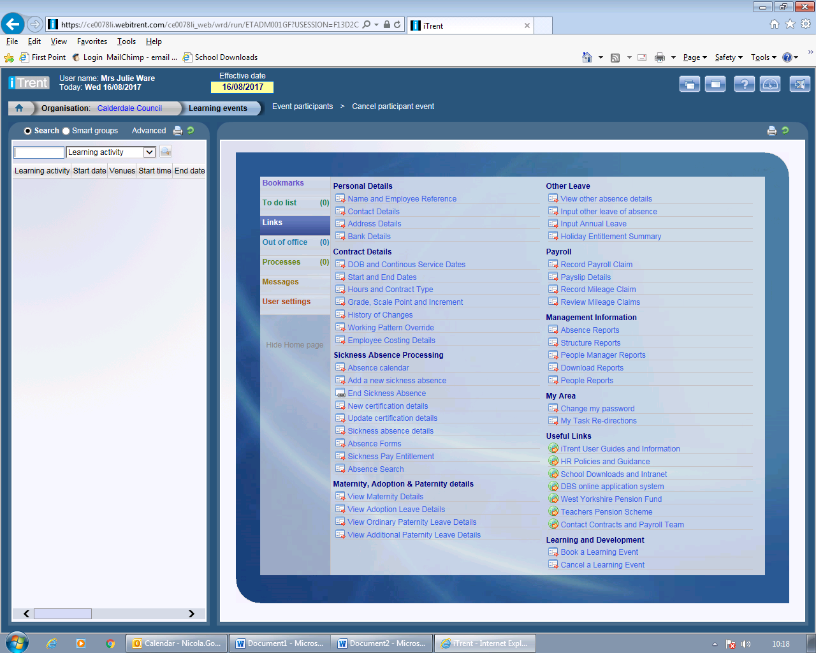

In the box on the left hand side type a *and a key word from the course title as detailed in the learning guide or on the confirmation.

Select the delegate name if you have booked more than one person on the course from the list on the left hand side.

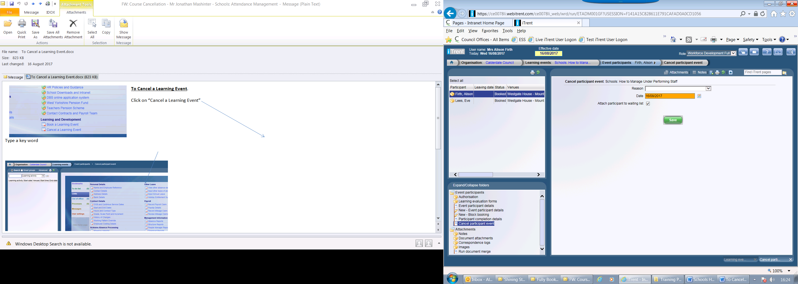

Select a reason from the drop down list. Amend waiting list check box if necessary and click “Save”. The system will auto generate and send confirmation directly from noreply@ce0078.webitrent.com.